Blankendaal, Peter (notes from Linked In website)
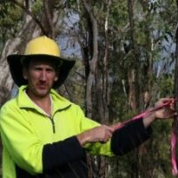

Educated at Bunbury TAFE.

Promoted to CALM Senior Dieback Interpreter Bunbury in 1996. Project Officer Glevan Consulting October 2006 – April 2010. Phytophthora occurrence mapping, Phytophthora management plans, Training Glevan employees in Phytophthora management and mapping. Client liaison, Quotes, Reports. Disease Standards Officer Western Australian Department of Environment and Conservation, DPaW February 2012 – in Bunbury. Disease Hygiene Coordinator Department of Environment and Conservation April 2010 – February 2012. Dieback mapping, Phytophthora management, Dieback Training.

